Grade 7 Accelerated · Unit 3 · Assessment  Exponents and Scientific Notation  41 points · two periods; students continue the same paper ANSWER KEY | Name  Date  Period

Show your work. Circle your final answer.
This assessment runs over two class periods. Stop when the period ends; you will continue from where you stopped.
If an earlier part is wrong, a later part still earns its point when the right operation is applied to your own earlier answer — but only if that work is on the page.
1. Laws of Exponents 9 points
1. Write each expression as a single power.
a. 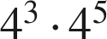 1 pt

Add the exponents; the base stays 4.
b. 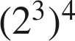 1 pt

Multiply the exponents.
c. 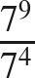 1 pt

Subtract the exponents.
d.  (give its value) 1 pt
1
Any nonzero base to the zero power is 1.
Scoring: a 1 · b 1 · c 1 · d 1 = 4 points.

2. Find the value of each expression.
a. 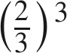 1 pt

b. 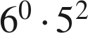 1 pt
25
1 · 25. A 0 here means 6⁰ was read as 0.
c. 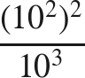 1 pt
10
10⁴ ÷ 10³ = 10¹.
Scoring: a 1 · b 1 · c 1 = 3 points.

3. Which expression is equivalent to 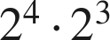 ? 1 pt
○ A. 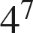
○ B. 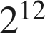
○ C. 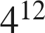
● D. 
D
Scoring: 1 point.

4. Find the value of that makes the statement true: 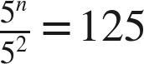 1 pt
n = 5
125 = 5³, so n − 2 = 3.
Scoring: 1 point.

2. Integer Exponents 11 points
5. Rewrite each expression with positive exponents. Do not evaluate.
a. 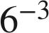 1 pt

b. 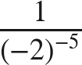 1 pt
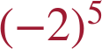
The power moves up; the base keeps its sign and its parentheses.
c. 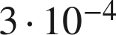 1 pt
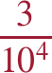
The 3 is a factor, not a base with an exponent; it stays up.
Scoring: a 1 · b 1 · c 1 = 3 points.

6. Find the value of each expression.
a. 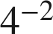 1 pt

Reciprocal of 4². −16 is the misconception; −8 multiplied base by exponent.
b. 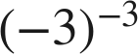 1 pt
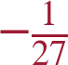
1 over (−3)³ = 1 over −27.
c. 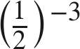 1 pt
8
Flip to 2, then cube.
d. 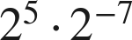 1 pt
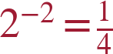
5 + (−7) = −2.
Scoring: a 1 · b 1 · c 1 · d 1 = 4 points.

7. Which is the value of 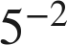 ? 1 pt
○ A. 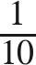
○ B. 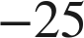
● C. 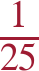
○ D. 
C
Scoring: 1 point.

8. Select ALL of the expressions whose value is 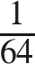. 1 pt
☒ A. 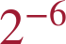
☒ B. 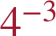
☐ C. 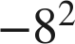
☐ D. 
☒ E. 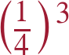
A, B and E
All three correct and nothing else for the point.
Scoring: 1 point.

9. Marco says the value of 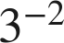 is 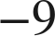. Explain why he is wrong, and give the correct value. 1 pt
A negative exponent means the reciprocal of the power, not a negative number. 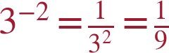.
The point needs the correct value AND the reason (reciprocal, not opposite). 'He forgot parentheses' is about (−3)², a different expression.
Scoring: 1 point.

10. Which is greater, 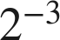 or ? Show how you know. 1 pt
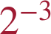 is greater. 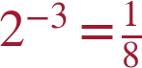 and 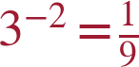, and 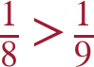.
Both values must be found; a guess does not earn the point. The reciprocals put the bigger denominator on the smaller number: 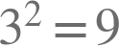 is bigger than 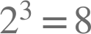, so 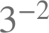 is the smaller of the two. TRANSFER ITEM — not on the practice test. Same benchmark, a surface nobody rehearsed.
Scoring: 1 point.

3. Variable Bases 9 points
11. Write each expression as a single monomial.
a. 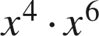 1 pt

b. 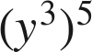 1 pt

c. 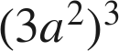 1 pt

The 3 is cubed as well. 3a⁶ and 9a⁶ are the two coefficient errors.
d. 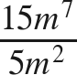 1 pt

Coefficients divide; exponents subtract.
Scoring: a 1 · b 1 · c 1 · d 1 = 4 points.

12. Rewrite each expression using only positive exponents.
a. 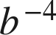 1 pt
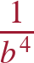
b. 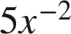 1 pt
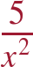
Only the x moves; 1/(5x²) moved the coefficient too.
c. 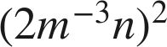 1 pt
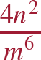
4m⁻⁶n², then m⁻⁶ moves down.
Scoring: a 1 · b 1 · c 1 = 3 points.

13. Which expression is equivalent to 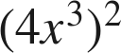 ? 1 pt
○ A. 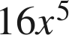
○ B. 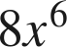
○ C. 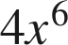
● D. 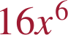
D
Scoring: 1 point.

14. How are  and 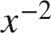 related? Explain, and give the value of each when 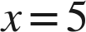. 1 pt
They are reciprocals: 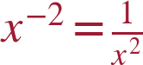. When x = 5, 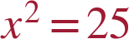 and 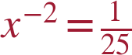.
The point needs the word reciprocal (or 1 over x²) and both values. −25 for x⁻² is the misconception.
Scoring: 1 point.

4. Scientific Notation 12 points
15. Write each number in scientific notation.
a. 8,300,000 1 pt
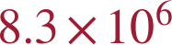
b. 0.00047 1 pt

The 4 is in the fourth decimal place; 10⁻³ counted the zeros.
c. 60,500,000,000 1 pt

The interior zero stays in the coefficient.
d. 0.0000000092 1 pt
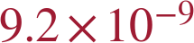
Scoring: a 1 · b 1 · c 1 · d 1 = 4 points.

16. Write each number in standard form.
a. 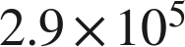 1 pt
290,000
b. 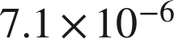 1 pt
0.0000071
Scoring: a 1 · b 1 = 2 points.

17. Which is 0.0036 written in scientific notation? 1 pt
○ A. 
● B. 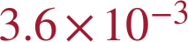
○ C. 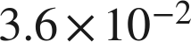
○ D. 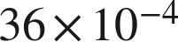
B
Scoring: 1 point.

18. Answer each question.
a. How many times larger is 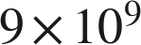 than  ? 1 pt
 times
9 ÷ 3 = 3 and 10⁹ ÷ 10⁶ = 10³. '3 times' ignored the powers; '30' read 10³ as 10.
b. How many times larger is 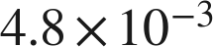 than 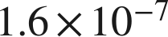 ? 1 pt
 times
4.8 ÷ 1.6 = 3 and −3 − (−7) = 4.
Scoring: a 1 · b 1 = 2 points.

19. Which is greater, 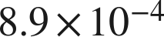 or 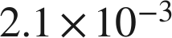 ? Explain how you know. 1 pt
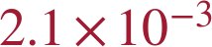 — the exponent −3 is greater than −4, so its power of 10 is larger; 0.0021 > 0.00089.
The point needs the choice and the reason. 8.9 × 10⁻⁴ compared the coefficients.
Scoring: 1 point.

20. A computer displays a number as 5.6E8. Write the number in standard form. 1 pt
560,000,000
E8 means × 10⁸.
Scoring: 1 point.

21. Between which two consecutive powers of 10 does 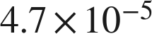 lie? 1 pt
Between 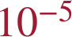 and .
4.7 is between 1 and 10, so the number is between 1×10⁻⁵ and 1×10⁻⁴. Both powers are needed for the point. TRANSFER ITEM — not on the practice test. Same benchmark, a surface nobody rehearsed.
Scoring: 1 point.

Score Tracker
41 points, one point per lettered part. Section 1 — 9 · Section 2 — 11 · Section 3 — 9 · Section 4 — 12
Benchmark | Questions | Possible | Earned
MA.7.NSO.1.1 | 1, 2, 3, 4 | 9
MA.8.NSO.1.3 | 5, 6, 7, 8, 9, 10 | 11
MA.8.AR.1.1 | 11, 12, 13, 14 | 9
MA.8.NSO.1.4 | 15, 16, 17, 18, 19, 20, 21 | 12
Total |  | 41

Follow-through (ruling 19). A later part is correct when the right operation is applied to the student's own earlier value. Look at what they wrote for the earlier part, do this part's operation to it, and tick if that is what they wrote. It applies only where the work is on the page.
Transfer items (ruling 18): questions 10 and 21. Neither surface appears on the review or in any question bank.

